

**MATHEMATICS  
METHODS**

**Test 5 –Differentiation and Applications of Differentiation  
Chapters 2 and 3 Sadler**

**Semester 2 2015**

**Section One – Calculator Free**

Time allowed for this section

Working time for this section: 20 minutes

Marks available: 17 marks

**Materials required/recommended for this section**

***To be provided by the supervisor***This Question/Answer Booklet  
Formula Sheet

***To be provided by the student***

Standard items: pens, pencils, pencil sharpener, eraser, correction fluid/tape, ruler, highlighters

**Important note to candidates**

No other items may be used in this section of the paper. It is **your** responsibility to ensure that you do not have any unauthorised notes or other items of a non-personal nature in the room. If you have any unauthorised material with you, hand it to the supervisor **before** reading any further. All working out **must** be shown for full marks to be awarded.

1. (5 marks)  
   Sketch the graph of a function that satisfies all of the conditions below. You do not need to determine the equation of such a function.

* The function cuts the x axis at (-6,0), (-2,0) and (2,0)
* The gradient of the function is zero at x = -4 , x = 0 and x = 4
* The gradient is positive for x < -4, 0 < x < 4, x > 4
* The gradient is negative for -4 < x < 0
* The graph cuts the y axis at -5

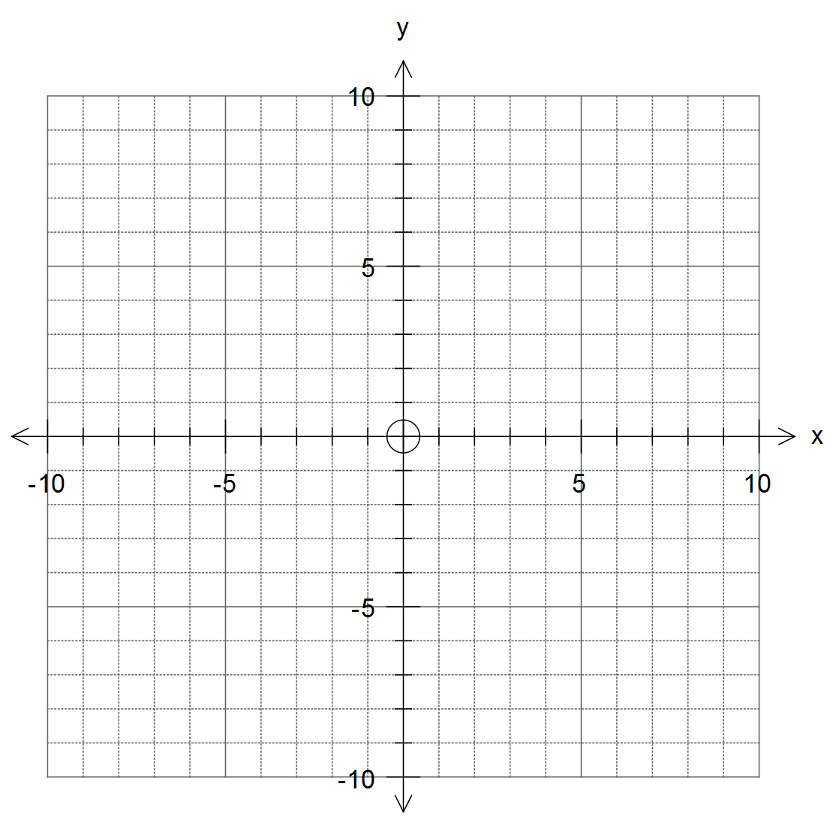

2. (8 marks)  
Find the derivative of the following functions.

1. y = 3x4 [1]

1. y = 3x2 – 2x + 5 [2]
2. y = (2x2 – x + 3)(4x – 5) [use the product rule for full marks] [3]
3. 2y = 4x2 + 6x - 8 [2]
4. (4 marks)  
   Find the equation of the tangent to y = 3x2 – x, at x = 3.

**End of Section One**